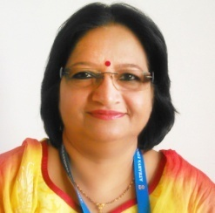

Name :Mrs. Shilpa Mistry

Designation : (HOD) Lecturer

Experience : 35 years

Qualification: MBA (IT & Systems) , B.E(Electronics)

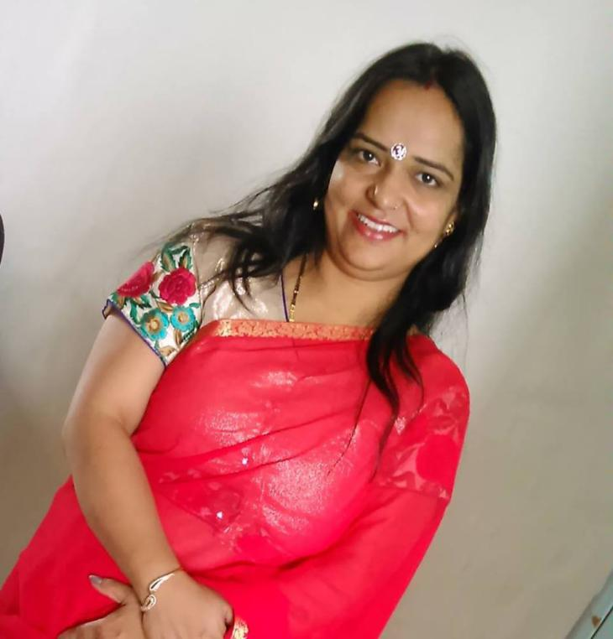

Name: Mrs.Aarti Oberoi

Designation : YCMOU Coordinator cum Lecturer

Experience : 15 Years

Qualification : M.Sc (I.T.)

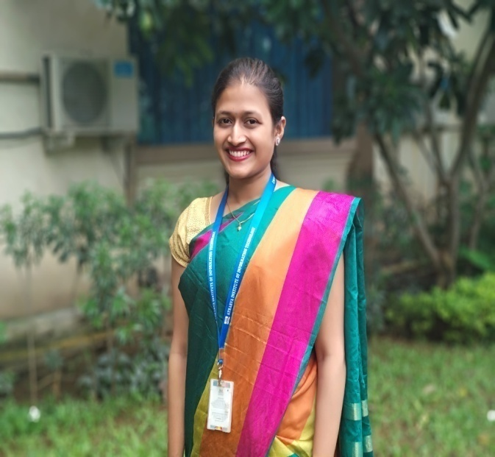

Name: Bhavika Joshi

Designation:Lecturer

Experience: 2 years

Qualification: B.E(Computer Engineering)

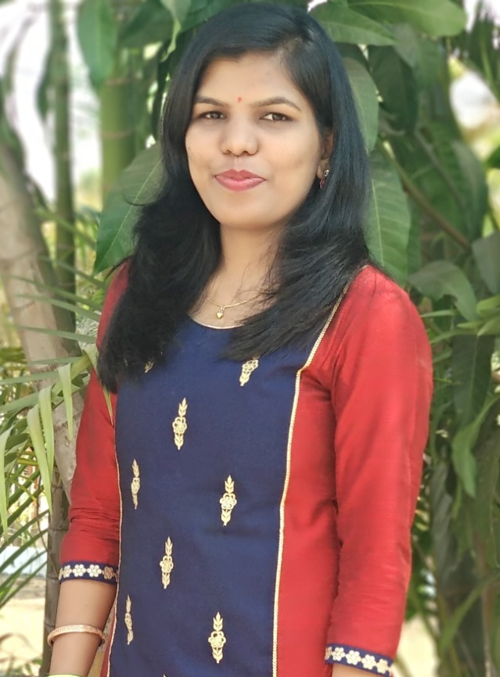

Name:-Jagruti Kadam

Designation:-Lecturer

Experience: 2 years

Qualification:-B.E (Information Technology)